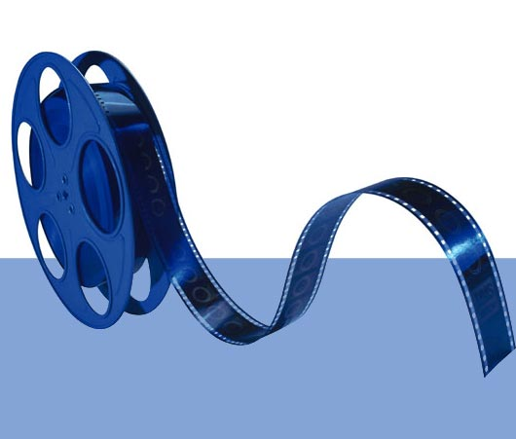
Burn Video DVD process

Video on the MiniDV format camera is digital video but needs to be captured onto a computer and saved as a computer file, normally .AVI

The video can now be edited cut copied effects added etc. Movie Maker is an easy to use video capture and editing program and is free with Windows XP SP2.

Your Video file/files can now be saved to a CD or DVD can now be viewed on a computer or home hard disk recorder/player but not on a normal home DVD player.

Video must be encoded to MPEG-2 format to be played on a normal DVD player. Encoding is part of the Burn Video DVD process only with software that supports this process. It's important that you select the DVI-AV (NTSC) file format when saving from Movie Maker if you plan to burn a video DVD.

Keep in mind that the process of encoding the movie into a DVD-compatible format can be quite lengthy. A 60-minute vacation video, for example, can take well over four hours to encode, and another 30 minutes or so to actually burn onto DVD. After you've created one DVD, you can immediately burn additional copies for friends and family without having to sit through the encode process each time.

During the Burn Video DVD process you can create a DVD menu that includes a background image and buttons for different chapters.

Use DVD-R to record your video, they are more reliable when playing on older DVD players. DVD-R are write once only where DVD+R are able to be added to with supportive software. DVD-RW are rewritable many times over.

Emerging formats for video include HD-DVD (Hi Definition) compatible to HD-TV and Blu-ray Disc (BD)

Compatible Software includes:
- Nero Vision Express 3
- Sonic DVDit!,
- neoDVD
- ULead's DVD products

