Buying a Computer

Understanding the Jargon is the first step to purchasing a computer.
The primary difference between a computer costing $1200 and a one at $2700 is the age of the technology if you want the latest fastest you pay. The $1200 computer was selling for $2700 last year; therefore the extra $1500 is buying you only 1 extra year. However there are a few things you should be aware of that can alter the price.
- What software is being offered
- What extras are being offered
- Do you need extra speed for game playing?

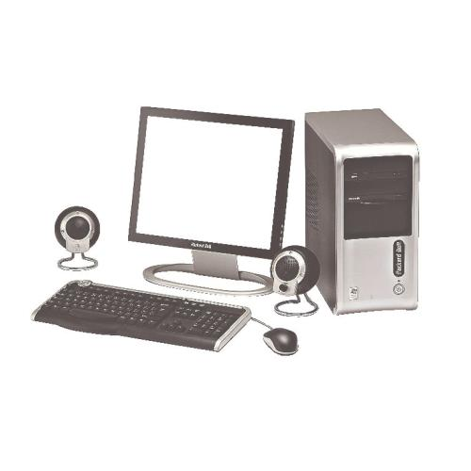
The Central Processing Unit (CPU) is the Brain of the computer and every year they get faster. There are two main manufacturers Intel and AMD, Current common models are the Intel Pentium or its cheaper model the Intel Celeron, or the AMD Athlon and its cheaper AMD Sempron. Our example below advertises an Intel Celeron
$1,499.00
Packard Bell iMEDIA M225 Personal Computer.
Intel® Celeron® D 2.93GHz, 1GB, 80GB hard disk, double layer DVD burner, 17" LCD screen, Windows® XP Home. P020313559

RAM (Random Access Memory)
This is likened to your work bench, the bigger the bench top the more work you can have active at one time. Current values are 256MB (Megabytes) to 2GB (2000MB) our example 1GB

Hard Drive (Hard Disk)
The computers filing cabinet or storage area in this case 80GB

CD – DVD Burner
In this case from the upper end of the market this unit being capable of writing a double layer of data on to a blank DVD (This unit would also be able to read and write to CD and CDRW). Other common units may be able to read a DVD but only write to a CD, or perhaps write to a CD but only write a single layer DVD.

Next the Monitor in this case a 17” LCD (Liquid Crystal Display) which is the modern thin screen, the older, deeper more common type would be called a 17”CRT (Cathode Ray Tube) other options include larger screen sizes 19 or 21 inch.

Lastly the Operating System in this case Microsoft Windows XP Home Edition no other software is advertised although most systems come bundled with some sort of Wordprocessor Spreadsheet and Email - Internet suite. This would indicate Microsoft Office® the most popular office suite is not included.

Other additions to advertised packages can include:
- More advanced Graphics Card (Better graphics rendering for video or games)
- Printer (Fairly useless with out one)
- Scanner (For digitizing pictures)
- Speakers
- Camera

