
Favorites

Find the Web page you wish to add to your favorites here I have chosen “www.ebay.com.au”

Choose Add to Favourites from the Favourites Icon

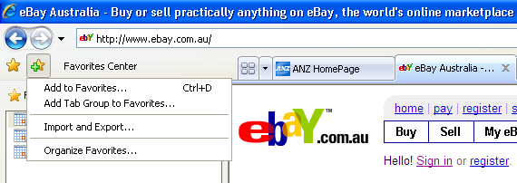

Use “Organize Favorites” to move pages into folders

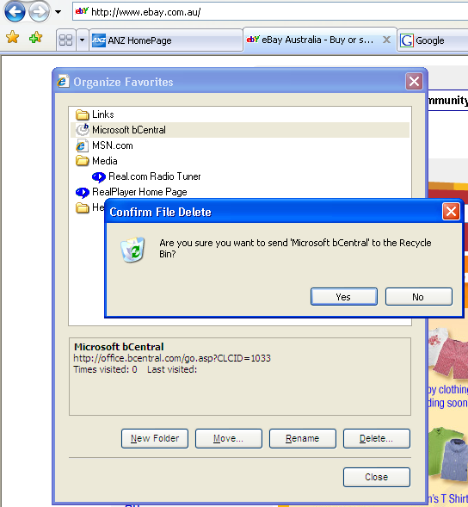

From the list of Favourites Web Links and Folders of grouped Favourites…

We can Delete no longer appropriate links…

Move links to folders…

Or rename our Favourite links

