
Tabs

With Internet Explorer 7 you can have multiple Web pages active at one time.
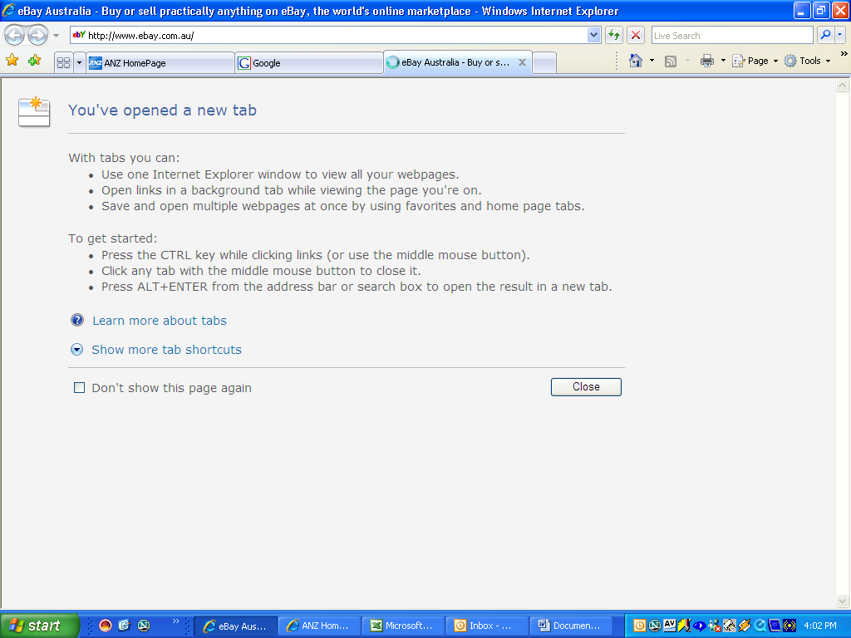
Click Here to Start a new Tab
Enter the address (URL) of the Web site you want to add and hit Enter
Click here to close a Tab

Multiple Tabs can be saved as Home Page Tabs and will consequently all load concurrently when you open your Internet Browser.

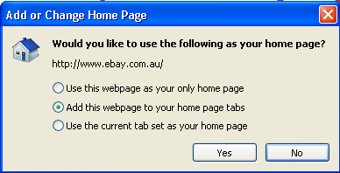
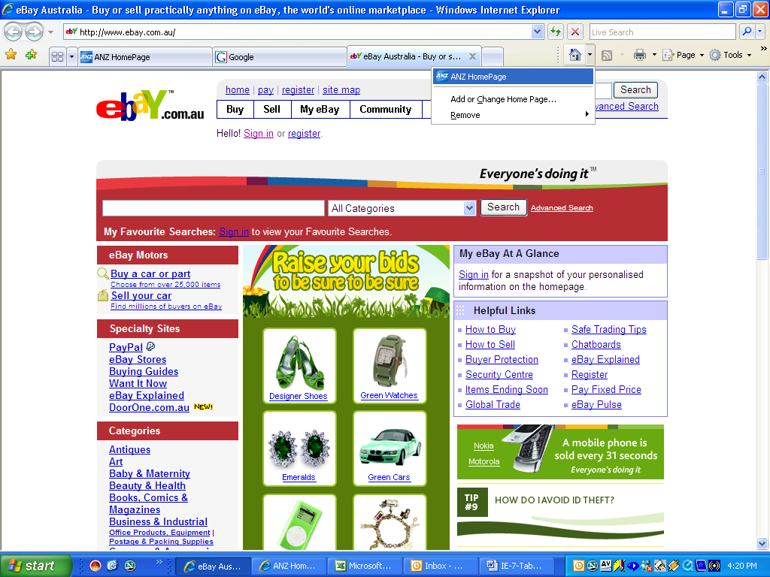
Click Add or Change Home Page from the Home Icon
From the Dialogue box that appears pick your option and “Yes”

