Emergency Information Record - Task.

First enter the information.

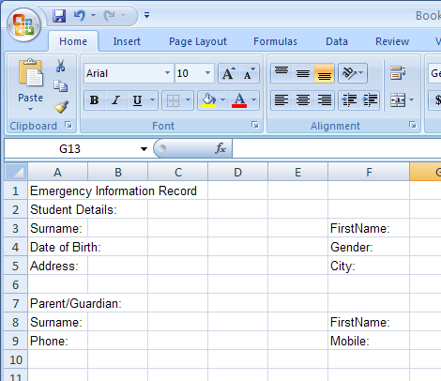
Disregard the overflow of text across other cells for the moment.
Choose Office Button> Print> Print Preview, this gives a picture of how the page would look printed. Then select Close to return to the spreadsheet.

Nb: You will need to go to Print Preview before the dotted page markers are visible.

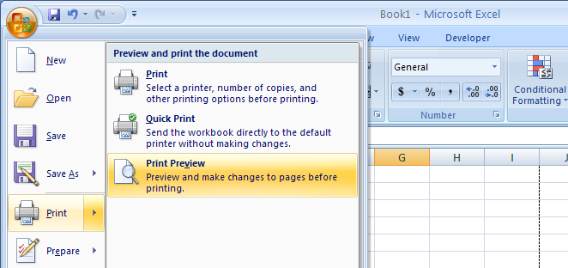

Next use the Formatting tools to customize your form.
Merge Cells:
Select the cells say, A1 to H1
Click the Merge and Centre tool to merge the cells A1 to H1 and centre the text within the new single cell.

With the cell A1 still selected change the Font Size to say 18pt.

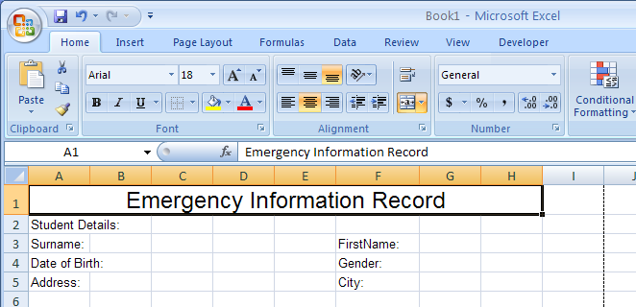

Include dotted lines:
Select a cell, group of cells or a merged group of cells, Choose Font and Border. Choose a Style and click on the bottom of the sample.

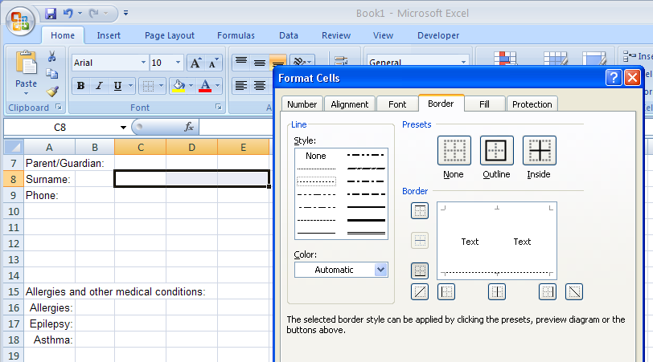

Alternatively Create Solid Borders:
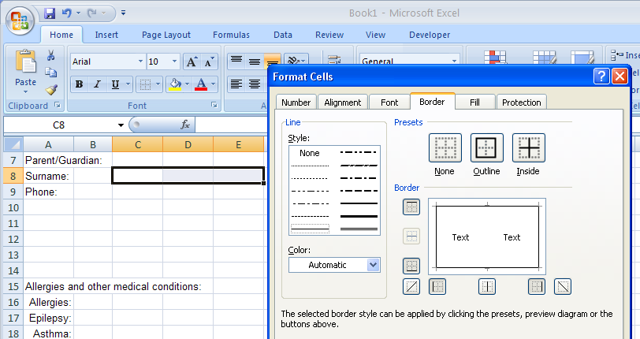
Choose a solid border style and click the sample.

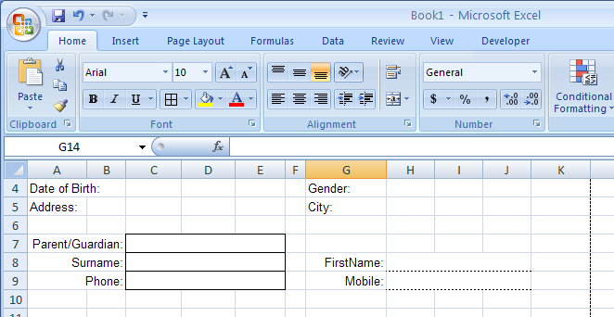
Perhaps use Right Align for some cells to more appropriately align the text.
You may need to Insert Columns as packing to align text and text boxes or fields. Insert is found on the right of the Home Ribbon.

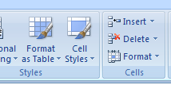

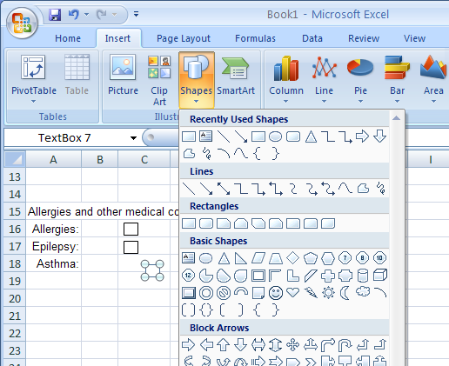
Tick boxes can be added
from the Insert Ribbon, choose a rectangle shape or a text box.

Nb: You may need to set the Shape Fill to No Fill and the Shape Outline to Black maybe even change the line Weight.

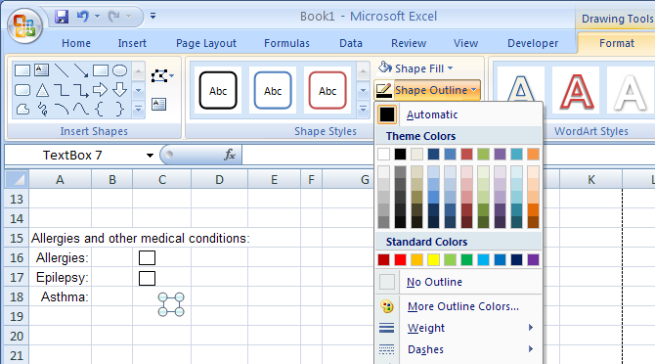
Tip: You only need to insert one Tick Box then Copy and Paste to duplicate and Drop and Drag them into place.

Ctrl + C to Copy
Ctrl + V to Paste

