Emergency Information Record - Task.

First enter the information.

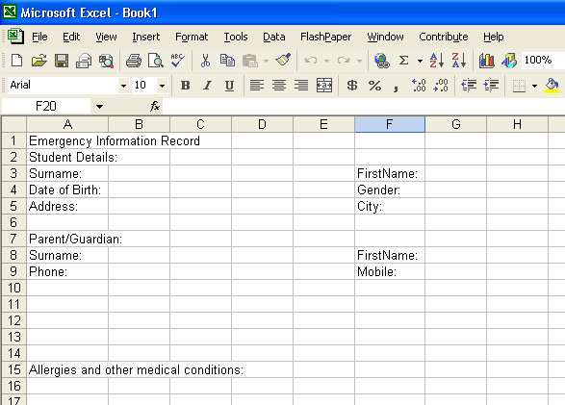
Choose File> Print Preview, this gives a picture of how the page would look printed. Then select Close to return to the spreadsheet.

Nb: You will need to go to Print Preview before the dotted page markers are visible.
Disregard the overflow of text across other cells for the moment.

Next use the Formatting tools to customize your form.
Merge Cells:
Select the cells say, A1 to H1

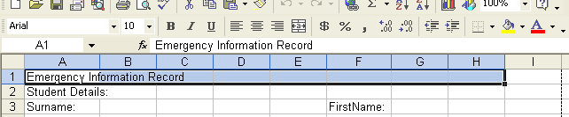
Click the Merge and Centre tool to merge the cells A1 to H1 and centre the text within the new single cell.

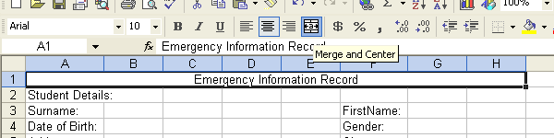

With the cell A1 still selected change the Font Size to say 18pt.
Increase Font Size:

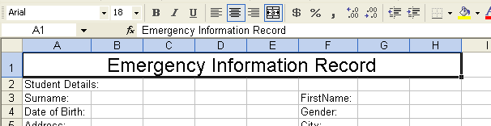

Include dotted lines:
Select a cell, group of cells or a merged group of cells, Choose Format> Cells> Border. Choose a Style and click on the bottom of the sample.

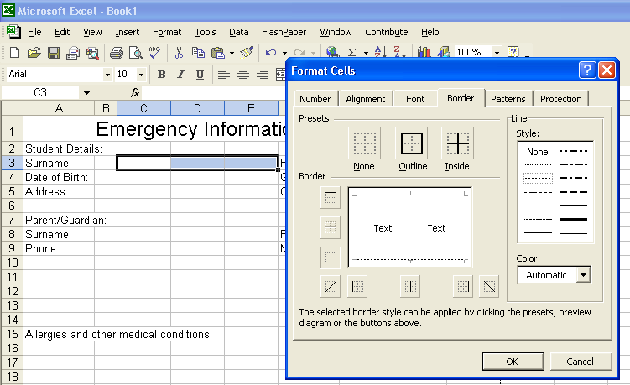

Tip: You can format all cells at once including non contiguous cells. Hold down the Ctrl key to select multiple cells.

Or format one cell and use the Format Painter to duplicate the formatting.

Alternatively Create Solid Borders:

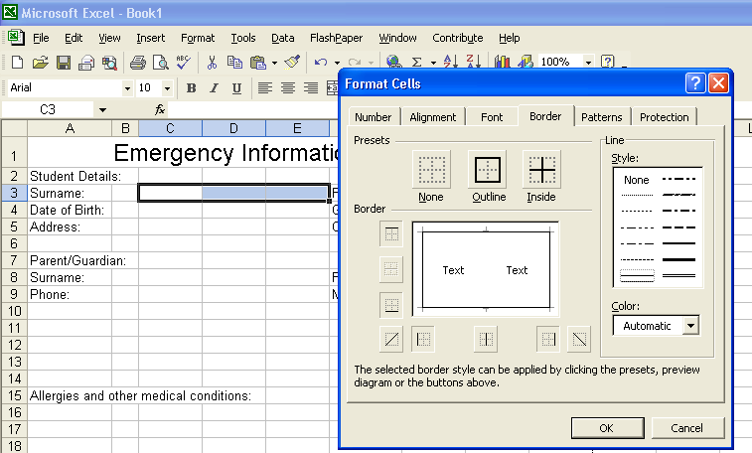
Choose a solid border style and click the sample.

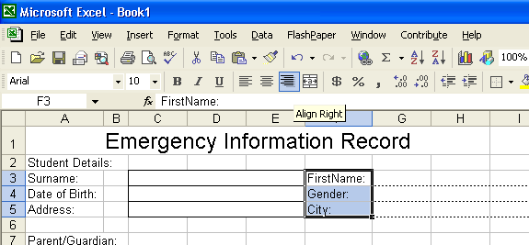
Perhaps use Right Align for some cells to more appropriately align the text.

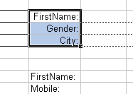
You may need to Insert> Columns as packing to align text and text boxes or fields.

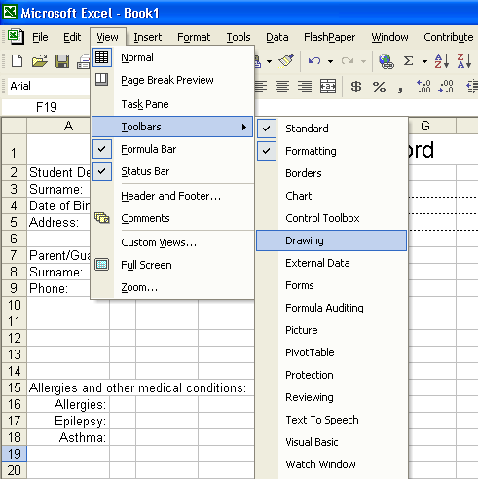

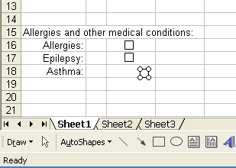
Tick boxes are best created by using a rectangle from the Drawing tool bar.

To find the drawing tool bar Select View> Toolbars> Drawing.
Tip: Draw one Tick box then Copy and Paste to duplicate additional uniform size boxes.

Ctrl + C to Copy
Ctrl + V to Paste

