BUDGET 2007
Create a budget in a Spreadsheet application as below.
Use AutoSum or manually type in the formula:
=Sum(B3:M3)
Then AutoFill the Rest of the sub totals.

Format the text in the cells where appropriate, change the size and colour etc.

Use Auto Fill® to fill in the Months

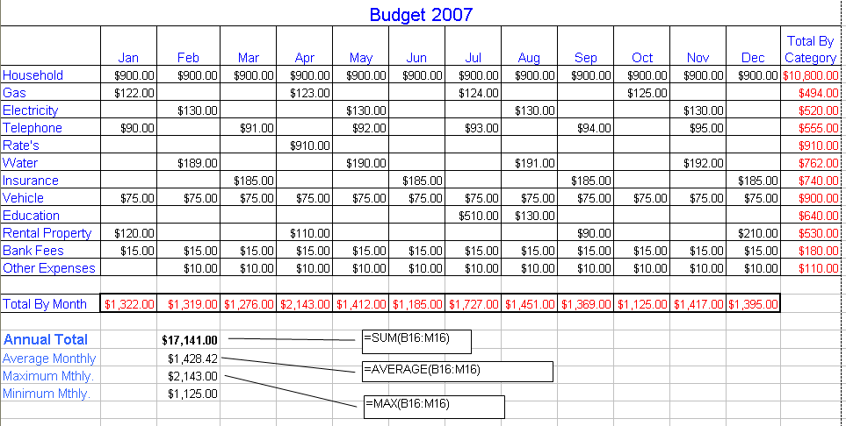
Enter these formulas to produce the totals.
Sum the Totals by Month.
Auto Fill the rest of the sub Totals

