Feathers ‘n Fins Invoice

Task: Create an invoice for a business in a Spreadsheet application similar to the one below.
Note the cell widths will need to be varied to accommodate this layout.

Start with 8 Columns (Width)


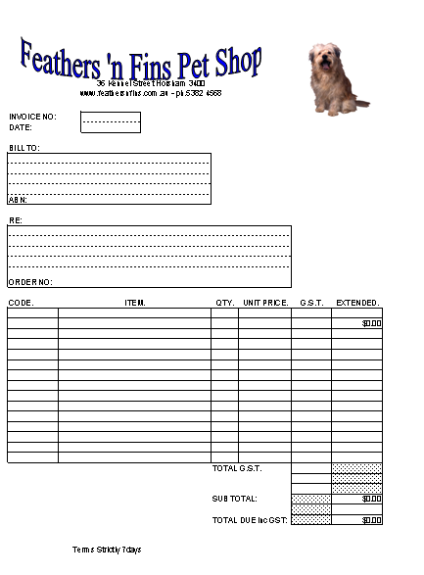
Include a picture from ClipArt®

Insert> Picture> ClipArt

Add a Text Box from the Drawing Tool Bar or Insert Menu.

Insert> Text Box

Add some WordArt®

Insert> Picture> WordArt

Merge Cells to set text area.

Format> Cells> Alignment> Merge Cells

Create borders dotted and plain:

Format> Cells> Border

Add dotted fill for unused cells.

Format> Cells> Patterns> Pattern

Align text within the cells where appropriate; Centre, Left or Right

Format> Cell> Alignment

Go to Print> Preview and adjust the Margins to accommodate fitting the invoice on an A4 sheet.

