Running Balance

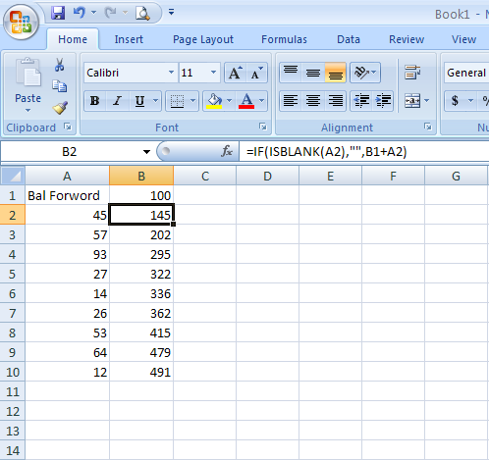
=IF(ISBLANK(A2),"",B1+A2)
Use this formula in cell B2 then drag the Autofill down the page.

