Netscape Composer – HTML Authoring Program
From the Browser Netscape Navigator:

Select - Menu> Composer
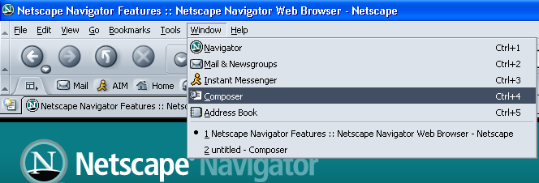

***********

Netscape Composer Layout

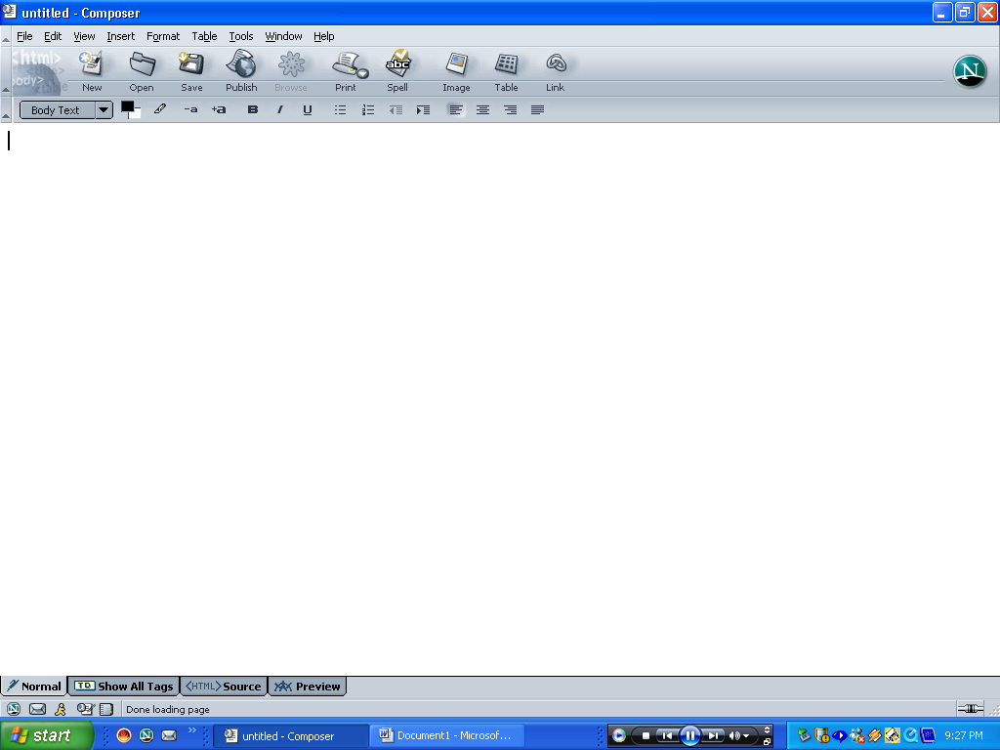
Tools for adding Tables, Images, Links and for formatting text.

Full options are available from the dropdown Menu’s.
The Tabs at the bottom of the workspace are used to choose which View you wish to use.

***********
Before you start

First of all it is advisable to create a special location for your Web files, this will help ensure all your images show and your links to additional pages work.

This could be C: ….My Documents/My Webs. Copy all your images here before you start.

If you are to publish your site, at some stage you will have to enter your hosting details into Composer or an FTP program.

Creating a Web Page
First insert a table to arrange objects on a page.
From the dialogue box choose 3 rows and 2 columns.

Instead of percentage for the width choose 774 pixels.

Normally the border would be “0” as it affects the entire table not the individual cells.
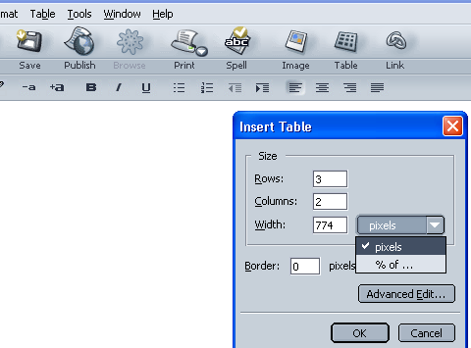
NB Although there are many ways to lay out a Web page including Layers and CSS, the easiest and most stable is the use of Tables with fixed pixel dimensions.

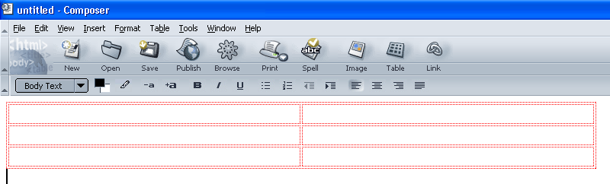

Cells can be merged or split to accommodate more complex page designs.

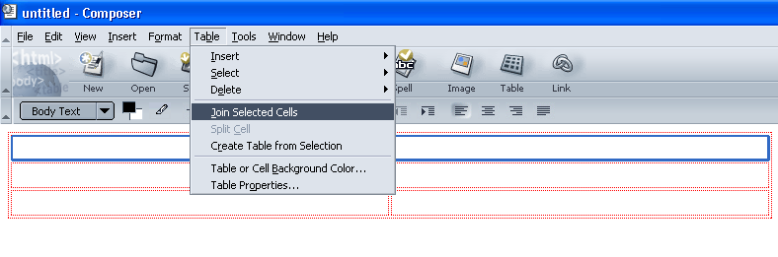
Select the top two cells and choose:

Table> Join Selected Cells.
Add a heading for your Web, select the text and choose: “Heading 1” from the Paragraph Format dropdown box.

NB Selecting a preset format for text allows for the inclusion of a CSS Style sheet which dictates the format of all instances of text with that given “Label”.

Individual formatting of text from the tool bar is satisfactory but it overrides any style sheet formatting.
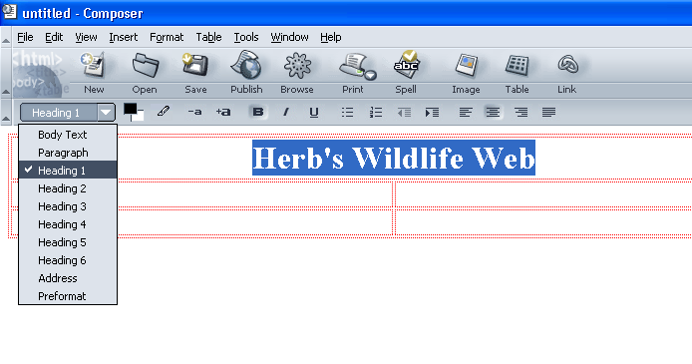
Using a Banner (Alternatively)
A banner is a composite image of pictures, graphics and text usually depicting the corporate image of a business. A banner would be created in a graphic program such as Adobe Photoshop® and saved in your Web folder.

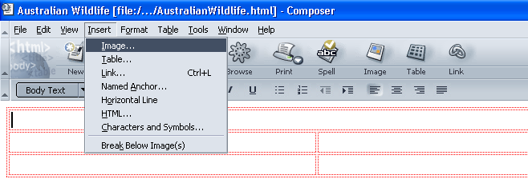
To add a banner choose Insert> Image

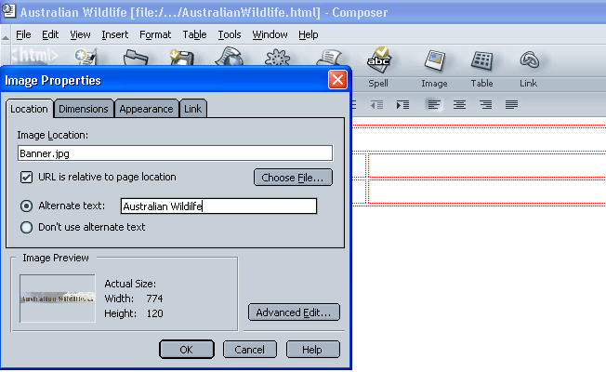
Locate your Banner image and choose OK.
Using Netscape Composer you will need to add some “Alternative Text” or specifically choose not to.

Alt Text is the picture title that displays on a yellow background as you hover over an image.

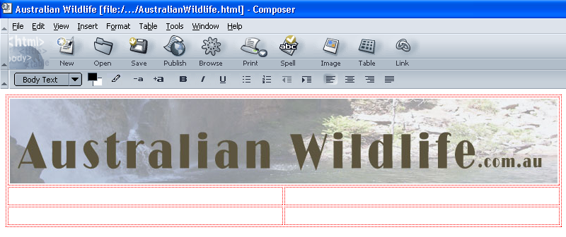

***********

Assuming we are not going to use a CSS style sheet to control the colour for our text, we can format our text to a set colour using the colour picker from the format tool bar.

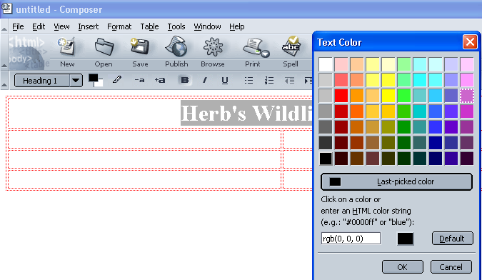

Let’s add a row as an after thought for a Navigation bar.

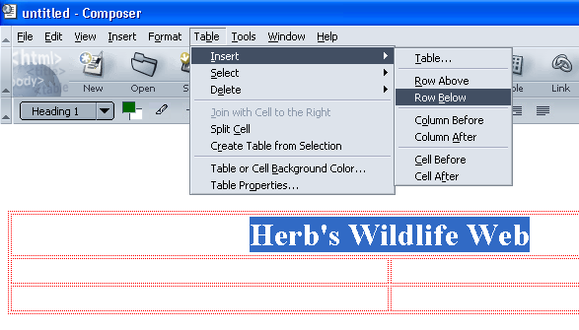
Select the top row.

Select – Table Insert> Row Below.

Next select the two new cells and merge as before.

Table> Join selected cells

***********

Add some Navigation headings.

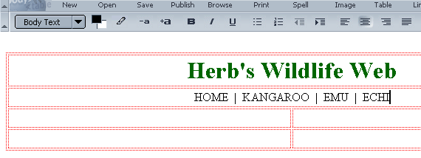
The vertical line between the headings is just for looks it is called a “Pipe” and is located above the Enter key on the normal Windows Keyboard.

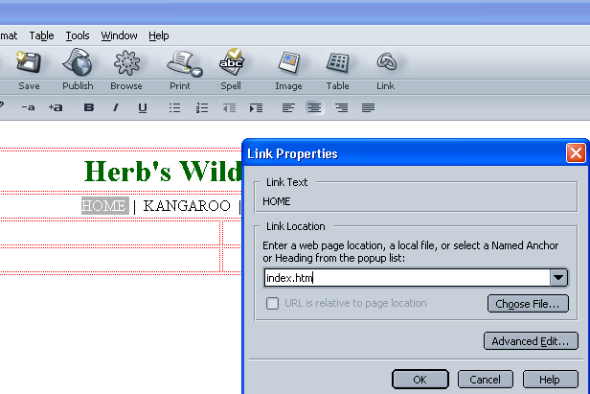
Select the “HOME” nav and click on link.

Type in a name for your home page normally “index.htm”

Continue to add the links for your other pages.

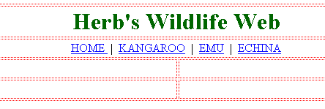

***********

Duplicate your Web pages

Choose: File> Save As>
- index.htm
Save as, in this case 4 times, one for each page.
- kanga.htm
- emu.htm
- echidna.htm

Add individual page content

Open each page in turn to add the individual page content.

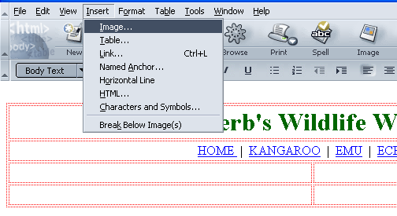
Select a cell and insert an image.

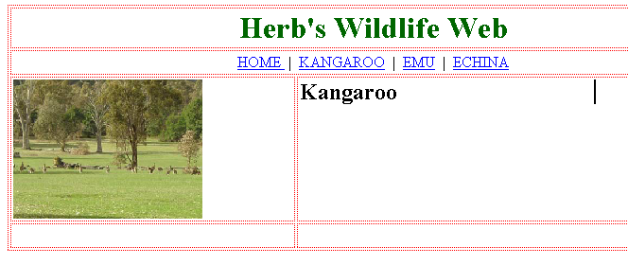
Add an image
Add some text to the neighbouring cell and format if necessary.
Text formatting can include font, colour and size also alignment (horizontal) and vertical alignment

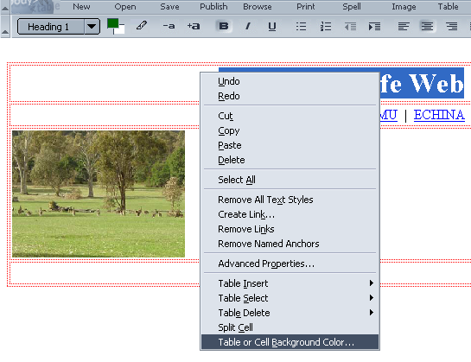
Right click on a cell or table to activate options for background colour and many other options.

