Merge Mail

Step One
Make a Mailing List and save it (eg. List.xls)

- Either in a Spreadsheet.
Name | Surname | Address | Town | Post Code
Bill | Smith | 2 Bridge Road | Ballarat | 3350
Sue | Jones | 45 King Street | Ararat | 3377

- Or in Word® in comma separated format.
Name, Surname, Address, Town, Postcode
Bill, Smith, 2 Bridge Road, Ballarat, 3350
Sue, Jones, 45 King Street, Ararat, 3377

Step Two
Open a new Word® Document and Save it (eg. Letter.doc)
From the Menu Bar click Tools> Letters and Mailings> Mail Merge

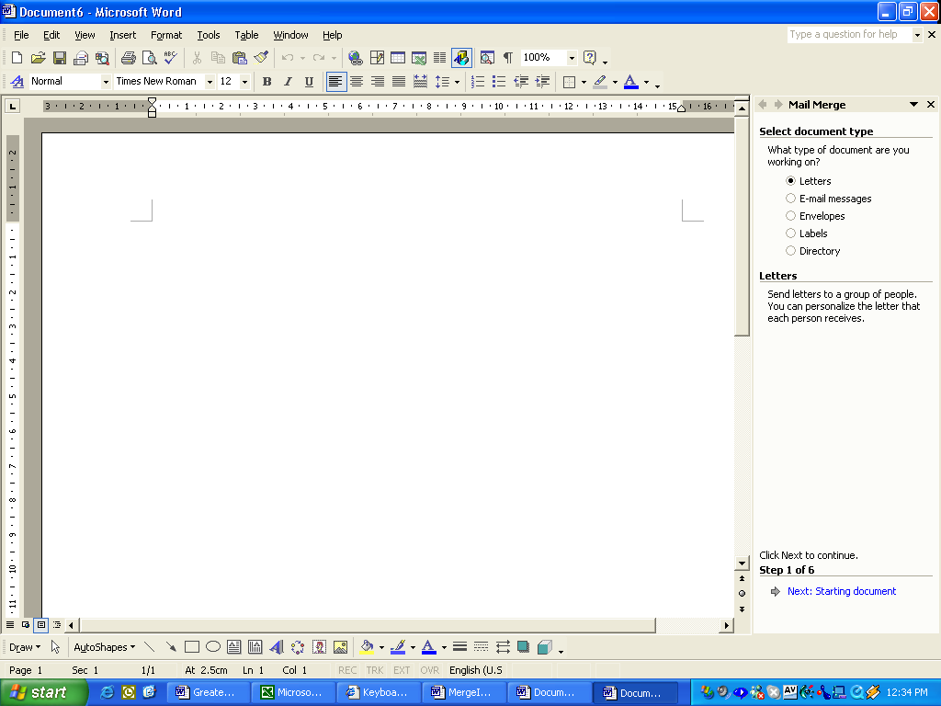
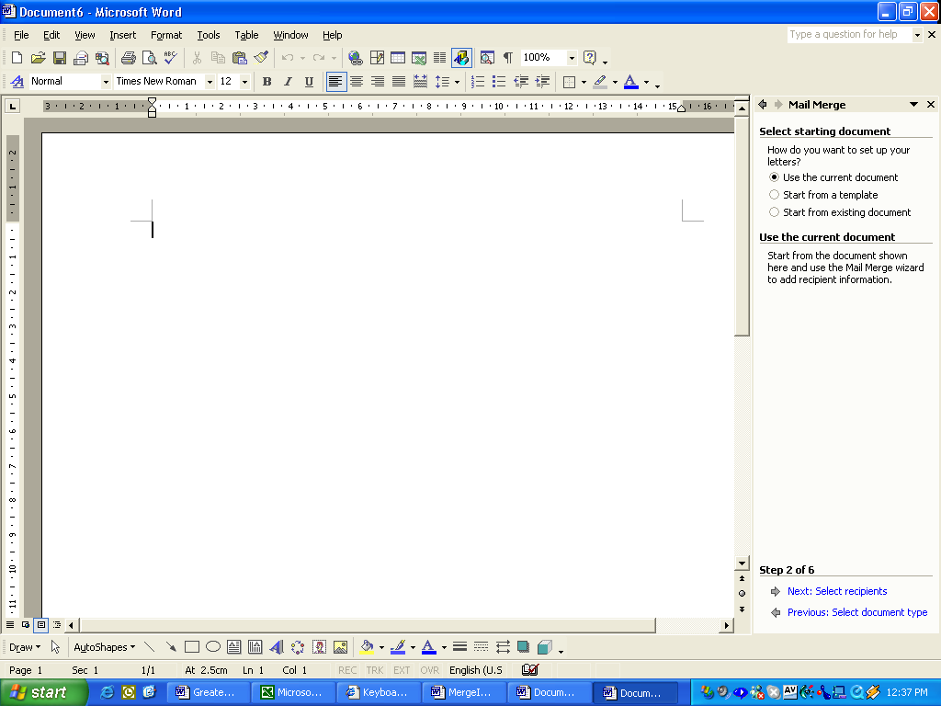
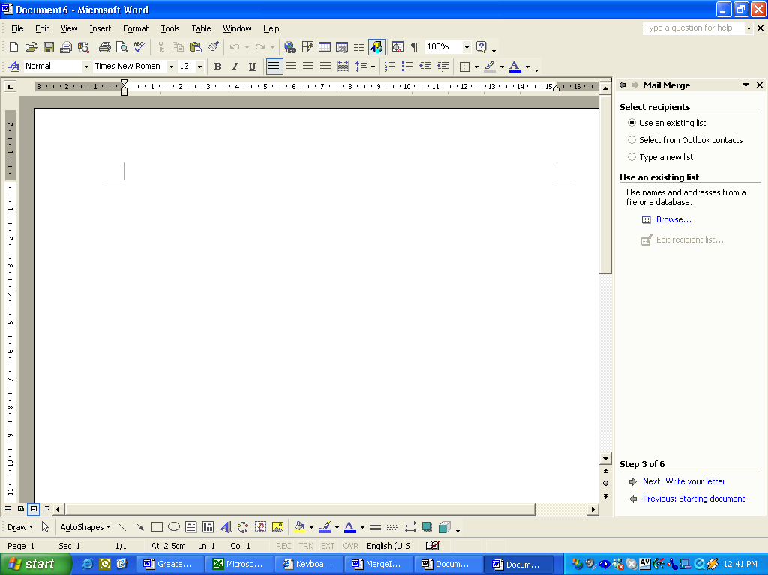

Choose Letter

Then Next

Use the current document

Next

Use existing list

Browse to find the list

Select the list

Next write your letter

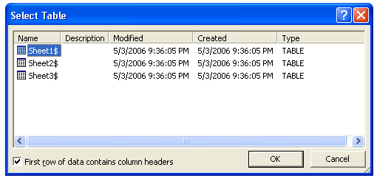
An Excel Spread sheet will show like this asking which sheet? Normally sheet 1

Make sure this box is checked if the first row is a Title Row.

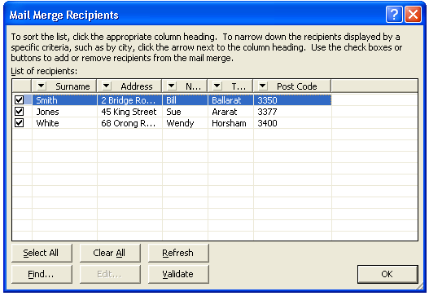
Your List should display like this.

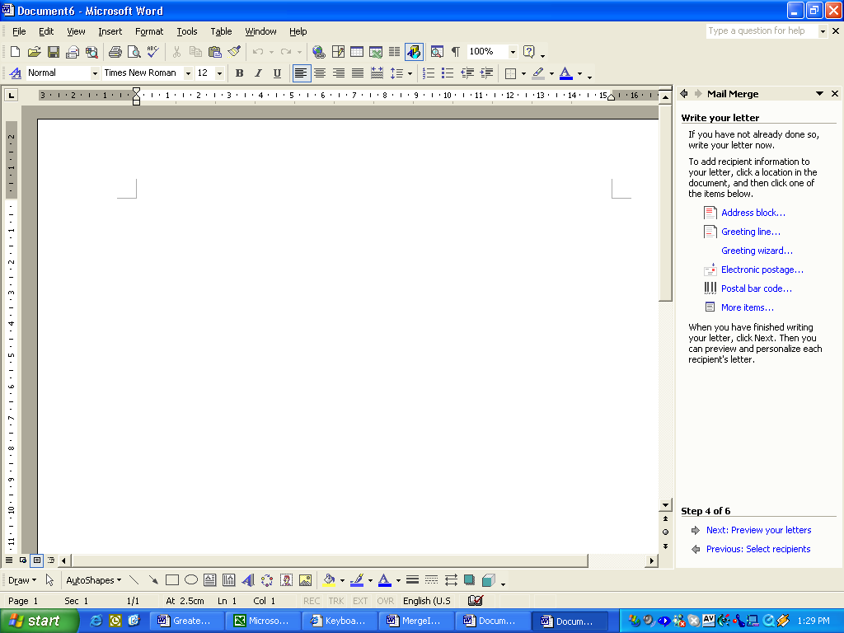

Type the letter. When you get to where you need to insert a field from your spreadsheet list (ie. Surname) select more items.

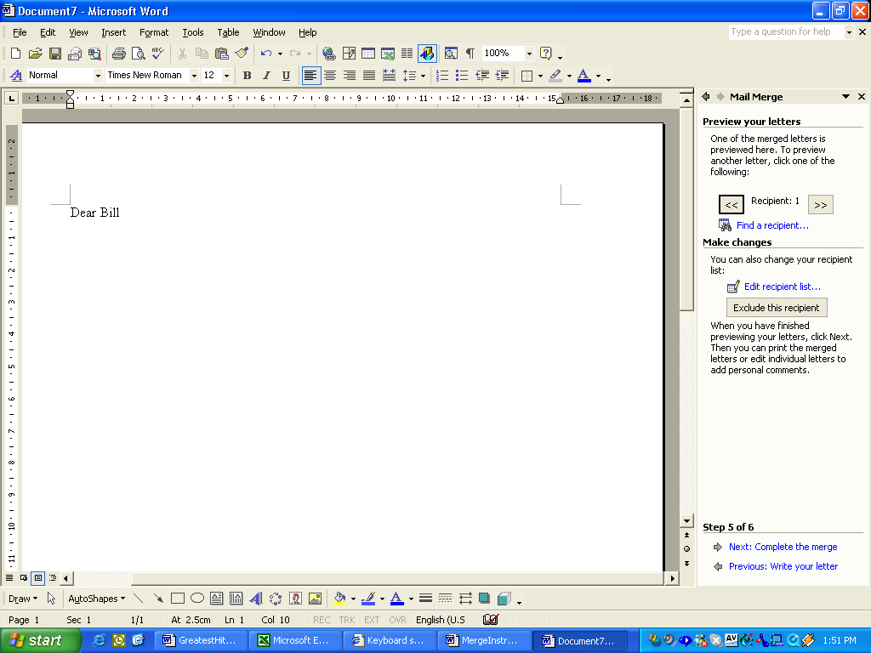
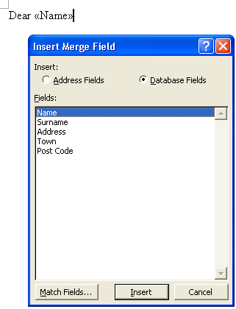
Select the required field

Then close the Dialogue Box.

Repeat for additional fields.

Next Preview the Letters.

Scroll through the letters editing where necessary.

Complete the merge.

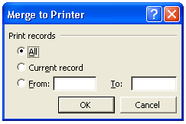

Select OK

Print the letters

