MSWord

Create a poster

Open Microsoft Word® or other Word Processor and enter the following Text.
At first just enter the text line by line ignoring the Formatting and Alignment.

Horsham Australia Day Carnival
26 Jan 2007
May Park Horsham
Free Admission
- Craft Stalls
- Local Produce Stalls
- Kids Rides
- BBQ
- Live Band
- Face Painting
- Raffles

Now you can Format the text by 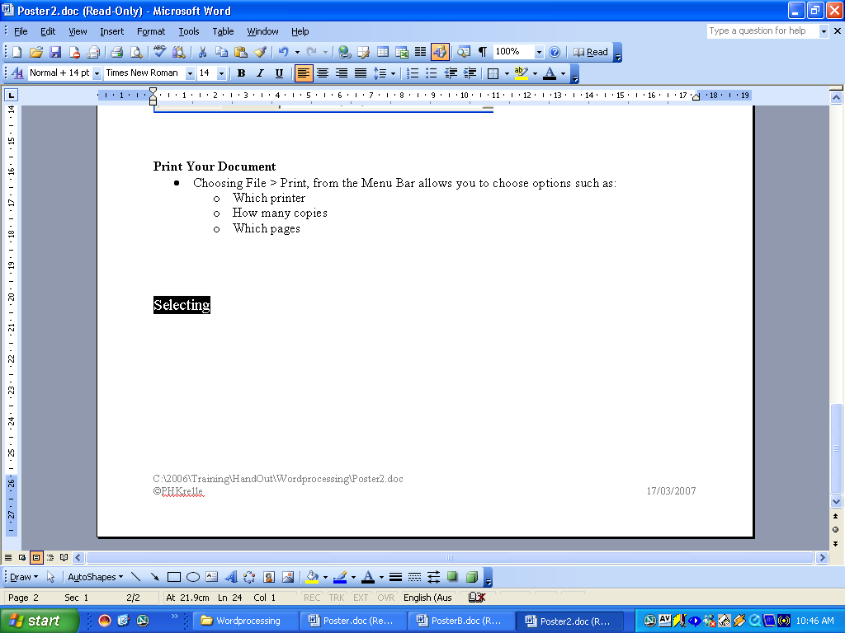 the required text and change the:

Font (Format > Font)
- Type Face – Times New Roman, Comic Sans MS
- Size (Common Unit 72pt = 1 inch)
- Style – Bold, Italics
- Colour

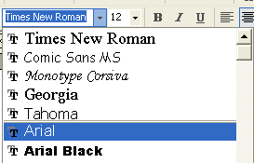
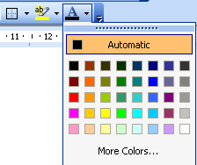

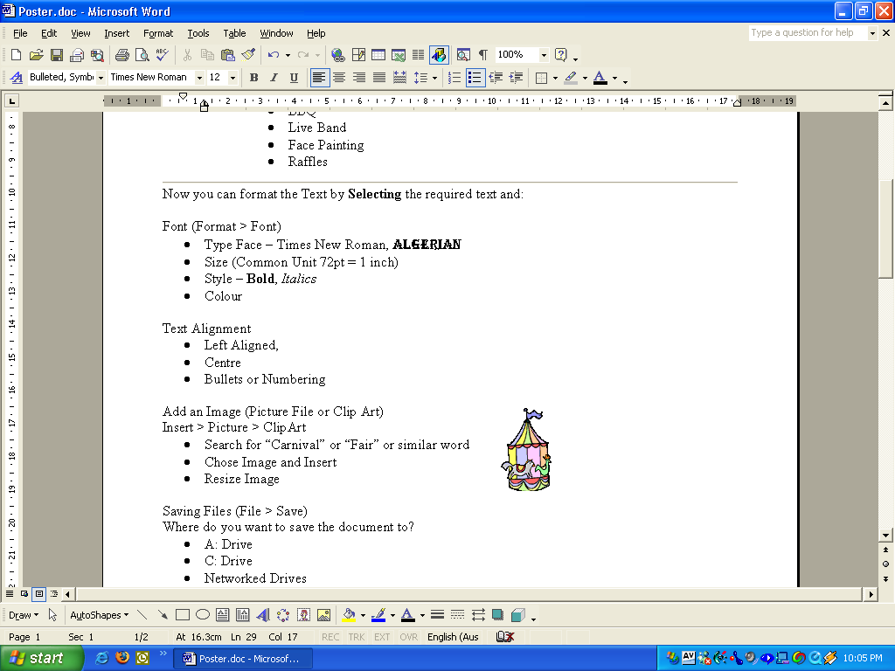
Text Alignment
- Left Aligned,
- Centre
- Bullets or Numbering

Add an Image (Picture File or Clip Art)
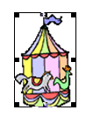
Insert > Picture > ClipArt
- Search for “Carnival” or “Fair” or similar word
- Choose Image and Insert
- To resize image click on the handles and Drag

Saving Files (File > Save)

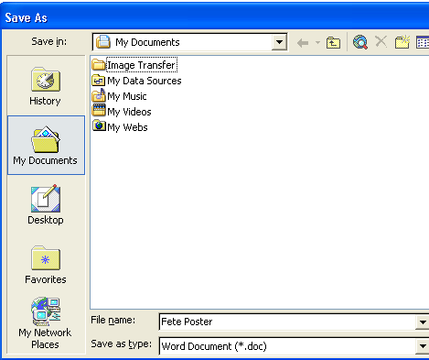
My Documents is a good place to save your work as it is normally the Default Folder on the Hard Disk “C:”
Give your new File a meaningful name.

Make a new personal folder to put all your files in within the My Documents Folder.

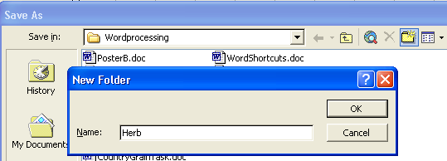
Click New Folder
Give your new folder a name

Print Your Document
- Choosing File > Print, from the Menu Bar allows you to choose options such as:
  - Which printer
  - How many copies
  - Which pages

